
Healthwatch City of London
Annual Business Plan
April 2026– March 2027

Contents page
Chair’s Introduction 3
Summary 5 - 6
The City of London 7 - 8
Vision, Mission and Values 9
Aims and Objectives 9
Statutory Duties 10
City of London Corporation Contract 11
Methodology 11
PEST Analysis 12 - 13
SWOT Analysis 13 - 14
Business Objectives 15 - 17
Financial Performance 17
Measuring Impact 18 – 19
Local Actions 20
Identified Risks 21
Contact Details 22

Chair’s Introduction
Welcome to Healthwatch City of London’s annual business plan for 2026/27. This plan underpins our contract with the City of London for the provision of Healthwatch services for the residents, workers and students of the City of London. We are delighted to be able to present this seventh business plan and the second as part of the award of the contract in September 2024. Healthwatch City of London is now in its eighth year, and we have gone from strength to strength.
The last year has been one of uncertainty as we awaited the outcome of the Dash review and then the details of the government’s 10-year strategy for health and social care which includes the winding up of Healthwatch. Whilst details are yet to be revealed of how scrutiny of health and social care will be managed and how the real voice of the public will be heard we have another year in which to continue our work.
Ensuring that current concerns and issues are addressed will be managed alongside working closely with partners to give greater strength and independence to the voice of users and receivers of services in any of the new arrangements as they emerge.
Addressing inequalities in access to services and the impact they have on health and outcomes remains at the core of what we do. Giving access to providers, exploring the impact of both national and local changes on our population and giving voice to the issues faced in a diverse population will continue to be a major part of our work. We will continue to build our networks with local people to enable those that come after us to build on firm foundations.
This year’s plans build on our momentum across the City. Our work in the Portsoken area in the city has really developed and we have some strong foundations established on which we can build.
We will continue to provide information on topics and issues that people want to hear about through our patient panels, which have proved very successful. Our projects reflect the concerns raised and we have tried to provide a broad range of topics. Social prescribing and the impact on both mental and physical health is of particular interest and at Healthwatch City of London we feel it’s important to further explore the concerns regarding the drive towards digital health care and the impact on those without access or who find that access is difficult or or otherwise impacts on their ability to maintain independence.
Once again, we concentrate on our five business objectives and our six local actions, as well as local actions and projects alluded to above that reflect our work with those experiencing the delivery of health and social care services in the city. Whatever their needs, we will aim to make sure people can participate in shaping services and challenge providers of care where necessary.
I would like to commend this business plan to you; building on last year’s successes, it sets out how we intend to discharge the contractual obligations and statutory requirements that need to be met, while ensuring that we do not lose sight of our key objective – to work for the people of the City of London in improving local health and social care services.
Gail Beer
Chair Healthwatch City of London
May 2026

Summary
Healthwatch City of London (HWCoL) is a charitable incorporated organisation, (registered number 1184771), licensed by Healthwatch England (HWE) to deliver the statutory obligations required in the Health and Social Care Act of 2012, and contracted by the City of London Corporation (CoL) to deliver those obligations. As a Charity, HWCoL is required to demonstrate that it delivers a public benefit, and as part of the HWE licence to operate, is required to demonstrate sound and inclusive decision-making. This business plan aims to deliver all these requirements and is underpinned by the organisation’s Vision, Mission and Values.
Healthwatch City of London is governed by an established Board of five Trustees, supported by three Board Associates and a permanent staff team of three (full time equivalent two). In developing this plan, the team undertook a thorough root and branch review of the previous year’s plan and achievements. This identified where improvements could be made, and how strategies and activities should be focused to meet the objectives.
The core work of HWCoL is to act on behalf of City of London residents, workers, and students as their independent champion to help improve local health and social care services.
As well as the requirement to meet national and contractual obligations, HWCoL prides itself on its localism and response to local issues, and the impact on local people. This business plan therefore contains a section addressing what is important to people who make up the City of London. This is reflected in the ‘local actions’ section as an output of the engagement work undertaken throughout the year.
The City of London is highly dependent on out-of-borough services to deliver both health and social care, and as such, the work of HWCoL is highly networked. A key objective is to ensure that partners in North East London (NEL) are made aware of the needs of the City and actively engage to enable full representation of the people living, working, and studying here.
In developing this business plan and building on the past six years, the Trustees determined that a full review of both the Political, Economic, Social, and Technological (PEST) analysis and the Strengths, Weakness, Opportunities, and Threats (SWOT) analysis needed to be undertaken. The full version of these analyses can be seen on pages 12-14).
The objectives for the year are supported by key tasks that enable the delivery of the plan and will enable HWCoL to meet the performance targets set out in the contract with the City of London Corporation, and those reflected in the Performance Framework by which the contract is managed, and impact assessed.
The report includes the expected financial performance of HWCoL over the length of the contract. HWCoL holds one contract with the City of London Corporation, its commissioner and sole funder. The management accounts for HWCoL for its fifth financial year of operation ending the 31 March 2024 show a surplus of £24,030. In February 2024 the City of London Corporation agreed funding until September 2024 of £42,624.54. The Trustees have a reserve policy to hold sufficient cash in the bank to cope with any unexpected cashflow issues over the length of the contract. Actual figures to be finalised.
The plan also includes a section on the risks to the organisation, and the mitigations required to manage those risks
The Business Plan is reviewed annually and referenced in the Annual Report, taking into consideration any contract changes, national and local policy changes, and feedback from stakeholders and service users.
Finally, the activities detailed in this plan will be used to support the delivery of the licensed activities of all Healthwatch in England.
This Business Plan covers year two of HWCoL’s contract, (April 2026 – March 2027)
The final objectives and plan were approved by the HWCoL Board at a private Board meeting on 18/07/2026

About the City of London
One of the reasons the Square Mile is unique is because of the number of people who live, work and visit. In just 1.12 square miles, according to City and Hackney Health and Wellbeing Population Profile (last updated in February 2026), there are 15,111 residents by ward, 13.6 % of whom are aged 65 or over. It is estimated that there are 676,000 workers in the City of London, or 1 in every 48 GB workers.
The City of London’s total population is predicted to grow 9.7% in the next ten years. The highest growth is projected among the older population, while the number of residents under the age of 40 is expected to reduce. The forecast change is smaller than the one predicted for London (7.2%), but London’s growth is also concentrated in the older age group.
Ethnic mix
The population of the City of London is diverse, although the majority of residents identify as White (69.3%). Asian residents make up 16.9%, Mixed ethnicity 5.5%, Black residents 2.7%, and Other ethnic groups 5.6%. However, in Portsoken ward, almost half (49%) of the population are ethnic minorities.
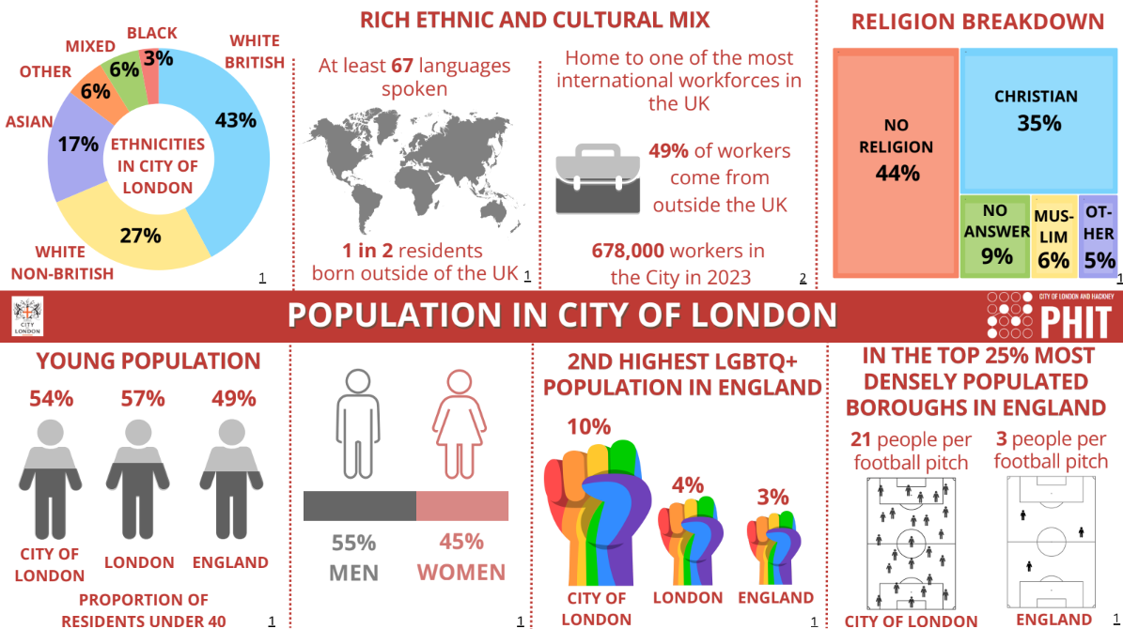 Source: City and Hackney Health and Wellbeing Profile- Population Infographic

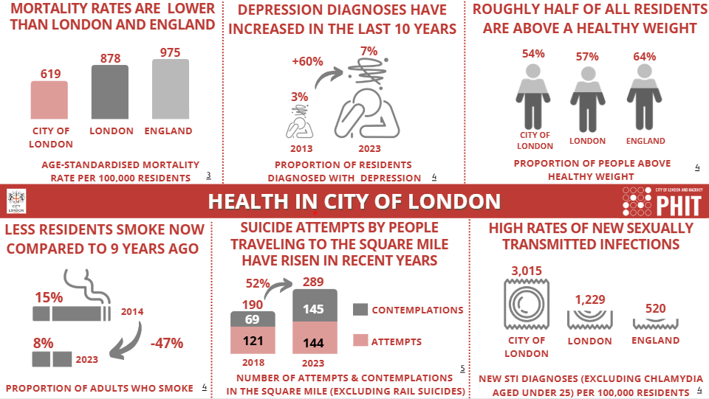
Influences on Health in the City
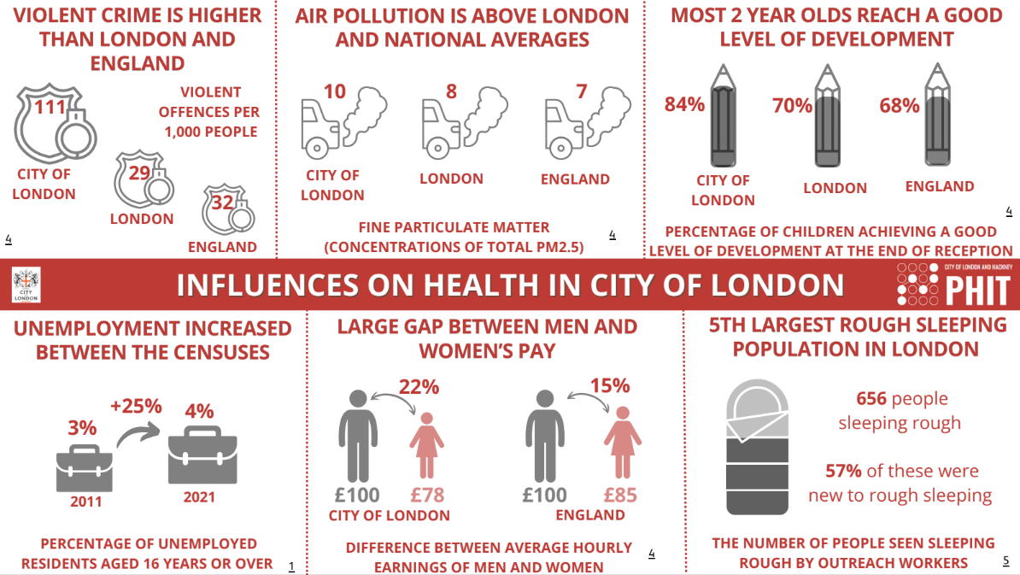
Source: City and Hackney Health and Wellbeing Profile- Health in the City Infographic

Vision, Mission and Values
The vision, mission and value statements describe the purpose of HWCoL and the core principles that underpin our work.

VISION
For Health and Social Care services to be truly responsive to the needs and requirements of the residents and workers of the City of London.

Mission
To be an independent and trusted body, known for its impartiality and integrity, which acts in the best interests of those who live and work in the City of London.

Values
- Respecting and encouraging diversity
- Valuing everyone’s contributions.
- Maintaining integrity
- Creating inclusiveness

Aims
City Focused: Relentlessly championing the voice of the user and would-be user in the health and social care system, ensuring that we give an opportunity for all voices from our diverse populations to be heard.
Accountable: Be open and transparent in all we do, actively involving residents and users of services in our work and the evaluation of our performance.
Connected: Help our populations to access high quality information about how their health and social care is delivered.
Networked: Recognise that the unique position of the City requires collaboration with other organisations, working with partners openly, constructively, and inclusively to support our shared purpose of improving health and social care services the City.
Value added: Be outcome focused in our work complementing, rather than duplicating, existing structures, within the resources available.
Evidence based: Gather and use local evidence to underpin our priorities and listening to all our local communities to target our efforts.

Healthwatch Statutory Duties
- Promote and support the involvement of local people in the commissioning, provision, and scrutiny of health and social care (local care) services.
- Enable local people to monitor the standard of provision of local care services and evaluate whether and how local care services could and ought to be improved.
- Obtain the views of local people regarding their needs for, and experiences of, local care services - and importantly to make these views known.
- Produce reports and make recommendations about how local care services could or ought to be improved. These should be directed to commissioners and providers of care services, and people responsible for managing or scrutinising local care services - and outcomes shared with Healthwatch England.
- Provide information about local health and social care services to the public in line with the Health and Social Care Act 2012.
- Formulate views on the standard of provision and whether and how the local care services could and ought to be improved; and share these views with Healthwatch England.
- Make recommendations to Healthwatch England to advise the Care Quality Commission to conduct special reviews or investigations. Where the circumstances justify doing so, make such recommendations direct to the CQC; and recommend that Healthwatch England publishes reports about particular issues.
- Provide Healthwatch England with the intelligence and insight it needs to perform effectively.
- Local Healthwatch organisations shall comply with all relevant legislation in force at any time during the contract period relating to the establishment and provision of the local Healthwatch service. As a provider of local Healthwatch services, HWCoL must also comply with all guidance issued in respect of local Healthwatch and its role and responsibilities. These are summarised on Healthwatch England’s website here.

The City of London Corporation Contract
The specification and commissioning of the Healthwatch contract is the responsibility of the Corporation’s Department of Community and Children’s Services. The current three-year contract awarded to HWCoL was agreed in September 2024, with an option to extend for two years.
The contract includes Quality Statements that provide a framework to support HWCoL and ensure that it is exerting its influence to secure better experiences for people using health and care services. These are:
A) HWCoL has a strong understanding of the strengths and weaknesses of the local health and social care system.
B) HWCoL enables local people to have their views, ideas and concerns represented as part of the commissioning, delivery, re-design and scrutiny of health and social care services.
C) HWCoL formulates views on the standard of health and social care provision and identify where services need to be improved by formally or informally collecting the views and experiences of the members of the public who use them.
D) HWCoL provides advice about local health and social care services to the public.
E) HWCoL works with Healthwatch England to enable people’s experiences to influence national commissioning, delivery, and the re-design of health and social care services.

Methodology
We developed our plan objectives in three stages:
- Desk top analysis of the external factors affecting HWCoL.
- Internal analysis using PEST and SWOT as tools to assist the process.
- Consultation on the draft Business Plan to ensure the plan met the expectations of residents and stakeholders.

Stage 1: DESKTOP analysis
The following documents provided an understanding of the influences that affect the delivery of Health and Social Care in the City of London.
Key documents:
- City of London Corporate Plan 2024 – 29
- North East London Integrated Care Board Operating Plan
- Pharmaceutical Needs Assessment 2025
- City and Hackney Joint Local Health and Wellbeing Strategy 2024-28
- City of London and Hackney Public Health Intelligence Team Strategic Plan 2023-2028

Stage 2: Internal analysis
HWCoL undertook PEST and SWOT analyses to understand the internal and external factors affecting the charity. Using these tools, HWCoL built on last year’s plan to develop this year’s plan.
The PEST analysis is based on Political, Economic, Social and Technological influences.
The SWOT analysis looks at the Strengths, Weaknesses, Opportunities and Threats.

PEST Analysis
Political  - Abolition of Healthwatch England and local Healthwatch in the proposed Health & Social Care Act  - Change of the role of the North East London ICB to strategic commissioning and reduced headcount.  - City and Hackney Integrated Care Partnership to be stood down as no longer a legal requirement.  - Government proposals leading to Patient Voice being lost due to Healthwatch being abolished and patient feedback to the ICB going online.  - Patient voice to be split, where the ICB responsible for Health voice, CoL responsible for Adult Social Care voice.  - North East London ICB- challenge of engaging with the new governance structures, City’s voice being lost.  - North East London Healthwatch (or replacement) organisations working collectively to influence NEL ICB, developing relationships and trust within Healthwatch.  - Collaboration between the new Neighbourhood way of working across NHS Trusts and the Primary Care Networks  - Service re-organisation over a larger geographical area impacting on residents as services become more remote. | Economic  - The impact on mental health and wellbeing of residents and workers because of the cost-of-living crisis.  - Increased social isolation caused by digitalisation impacting those who do not have access to the internet or smartphones.  - Digital divide creating a two-tier access to health and social care, creating further health inequalities which could impact people’s ability to work  - Funding of health and social care services at risk.  - Large scale transformation programmes in public services without effective public engagement that could impact on provision of services.  - Alternative models for delivering health and social care services at a local level.  - GDPR regulations-cost of compliance in a greater digitalised world.  - Transformation of office space into housing in the City - increased pressure on the City’s residents’ services  - Sustainability of the NHS and Social Care in an aging population
Social  - Increasing polarisation and division caused by social media – increasing social anxiety and isolation.  - Using social media/AI for health information which is incorrect. The impact on mental health and wellbeing of residents and workers due to long waiting lists and lack of resources impacting on mental health services.  - Health Inequalities across City and Hackney. Availability of services in the City.  - Lack of a City specific Council for Voluntary Services  - Increased social isolation as a result of digitalisation with services not being developed to address this.  - Backlog in secondary care for treatment impacts on local health needs.  - Understand better the access to affordable provision of dental care impacts on health and wellbeing of the local population.  - Social isolation in West of the City (Barbican and Golden Lane) | Technological  - Greater digitalisation of health and local authority services, creating a digital divide and greater inequality.  - GDPR compliance in a digital world - contacting our communities will require sharing of digital information.  - Greater user of digital programmes to deliver HWCoL objectives.  - Generating insights from data we collect.  - Improving digital skills to keep pace with change.  - Digital volunteering is going to grow.  - Digital by design marginalises the end user in the development process.  - Safeguarding vulnerable individuals whose voice is lost in the digital world.  - Drive to move from analog to digital will impact access to services.

SWOT analysis
Strengths  - Support of the City of London.  - Engaged and motivated Board.  - Majority of Board are City of London residents.  - We have a clear vision, mission, and values.  - Staff team work effectively and are highly motivated.  - Board and staff are well networked.  - Nimble and able to react quickly.  - We understand our population.  - Well established local networks  - Good engagement with local Councillors  - Respected across ICB and Healthcare partners.  - Active and trusted in the local community | Weaknesses  - Reliant on one funder.  - Control of office environment & access for the public.  - Small team will struggle to carry out the work required without a supportive team of volunteers.  - Diversity of Board (age and ethnicity)  - City worker engagement.  - Access to unheard groups  - Involvement and engagement with younger people.  - Recruitment & retention of staff in a competitive market  - Recruitment and retention of a skilled volunteering team supporting our work.  - Engagement with social care
Opportunities  - Generate new funding streams.  - Involvement in Neighbourhoods  - Create greater engagement with seldomly heard groups.  - Increased partnership work with local charities and Healthwatch.  - New projects - develop our knowledge, grow the charity, increase our reach, gives us authority.  - Opportunity to relaunch as a more bespoke community service.  - Research benefits us to influence change, build our reputation, develop our unique Selling Point through City specific projects.  - City workers’ engagement to build our brand, through unique projects, research, and funding.  - Volunteers – ambassadors for HWCoL.  - Work with the Shoreditch Park and City Primary Care Network on patient engagement.  - Continue work with the Neighbourhood forum for Shoreditch Park and City to responsive to the needs of local people.  - Work with Secondary Care partners especially Barts Health and University College Hospitals. | Threats  - Rent-accommodation costs are too high for our budget.  - Small budget - HWCoL may not be able to produce work to the standard expected.  - Proposed abolition of Healthwatch and consequent loss of statutory powers, leading to reduced ability to influence providers.  - Not able to recruit volunteers and Board members impacting on HWCoL’s local networking and knowledge.  - Overextending ourselves.  - Funding cuts and opportunities impacted on as a result of the new Health and Social Care Bill.  - Engagement - failure to engage across our local communities, resulting in us not delivering on our mission.  - Lack of diversity in Board - our diverse community not seeing us as relevant.  - Loss of centralised support due to proposed abolition of Healthwatch England  - Primary Care Networks not responsive to the needs of City residents by locating services in GP practices not used by city residents – going to other GP services to access services  - Difficulties in accessing students and City workers.  - Lack of City-specific data to support our work in relation to access to Health services, health inequalities and health outcomes

Stage 3: Consultation
The consultation on the annual plan will take place in June 2026. The consultation will last for a 14-day period.
We will continue to refine the plan as new issues emerge and as partners scrutinise our work.
Key stakeholders include:
- North East London Integrated Care Board
- City and Hackney Public Health Team
- Shoreditch Park and City Primary Care Network
- City of London Health & Wellbeing Board
- City of London Department of Community and Children’s Services
- City of London voluntary sector
- Healthwatch England
- Local Acute Trusts
- Voluntary Sector partners including HCVS, Age UK and MIND

HWCoL will seek comment on the plan from City residents and stakeholders via an on-line survey.

Business Objectives
Using the outcome from the PEST and SWOT analysis, along with feedback from engagement activities with City residents, students, and workers, and conclusions drawn from our desktop analysis, HWCoL identified the following objectives that will make a difference to City residents’ experience of Health and Social care. The objectives are deemed essential to be achieved to serve the people of the City of London and ensure the viability of HWCoL beyond the fifth year of the current contract. HWCoL will continue to work towards achievement of the following objectives so that:
1: HWCoL’s voice is recognised: representing the City of London’s residents, workers, and students, ensuring that their voice is heard in every forum where change to the delivery of health and social care is discussed.
2: HWCoL recruits and retains a team of committed volunteers: to deliver our vision through a range of bespoke opportunities.
3: HWCoL is a trusted partner:
- trusted by City residents, students, and workers to raise the issues important to them, with those taking decisions affecting their health and social care needs.
- trusted by the bodies taking decisions, ensuring that they seek HWCoL’s views as an organisation they need, due to HWCoL’s reputation as a reliable source of patient feedback.
4: HWCoL delivers informative research: that impacts positively on City of London residents’, workers’, and students’ experience of health and social care services and outcomes.
5: HWCoL is financially stable: holding sufficient cash in the bank to manage any unexpected cashflow issues over the length of the contract.
Business objective One 2026/7
1: That HWCoL’s voice is recognised: representing the City of London’s residents, workers, and students, and ensuring that their voice is heard in every forum where change to the delivery of Health and Social Care is discussed.
Target:
1.1) Engage with residents, workers, and students in the City of London to discover what is important to them.
1.2) Support our community, enabling it to be consulted and involved in the commissioning, provision, and scrutiny of local care services.
1.3) Seek to ensure that the Integrated Care Board for North East London, Shoreditch Park and City PCN and the Neighbourhoods Team are committed to co-development and are consulting effectively with the public on the planning and delivery of services.
Business objective Two 2026/7
2: HWCoL recruits and retains a team of committed volunteers: deliver our vision through a range of bespoke opportunities.
Target:
2.1) Build an effective volunteer team by ensuring that the recruitment, management, and development of volunteers comply with statutory requirements and HWCoL policies.

2.2) Deliver the commitments to good practice in supporting and managing volunteers identified in HWCoL’s volunteer charter.

2.3) Identify volunteering opportunities that enable participation from our diverse communities within the City, enhancing the work of HWCoL.
2.4) Ensure that HWCoL recognises the time our volunteers commit and the value of their work.

BUSINESS OBJECTIVE THREE 2026/7
3: HWCoL is a trusted partner:
- trusted by City residents, students, and workers to raise the issues important to them, with those taking decisions affecting their health and social care needs.
- trusted by the bodies taking decisions, ensuring that they seek HWCoL’s views as an organisation they need due to HWCoL’s reputation as a reliable source of patient feedback.
Target:
3.1) Demonstrate HWCoL’s quality as an organisation.
3.2) Be open and accessible to City residents, students and workers through the provision of opportunities to engage and raise with HWCoL issues that are important to them in relation to their health and care, via face-to- face and on-line forums.
3.3) Work in partnership with local bodies and Healthwatch across North East London to embed Co- Production and resident engagement in the developing structures for NHS North East London health and care partnership / integrated care board
3.4) Collaborate with local bodies on placing patients at the centre of the decision-making process about their health and care needs.
3.5) Support both statutory and voluntary partners in delivering their health and social care campaigns and programmes, providing feedback from City residents, workers, and students when necessary.
3.6) Research the specific health and care needs of City workers and work to address them.
3.7) Respond to both local and national consultations, making sure the City of London voice is heard and is representative of service users.

Business objective FOUR 2026/7
4: HWCoL delivers informative research: that impacts positively on City of London residents’, workers’ and students’ experience of health and social care services and outcomes.
Target:
4.1) Carry out research, driven by residents, workers, and students of the City, which reflects their priorities, concerns and requirements.
4.2) Undertake small research projects that enable HWCoL to identify issues and gaps in services or support and confirm/disprove assumptions on delivery or need.
4.3) Deliver research projects that are City-specific, but impact on the wider landscape.
4.4) Support and participate in research projects developed by partner organisations that demonstrate enhancement of care or enable the voice of local people to be heard.
Business objective FIVE 2026/7
5: Ensure HWCoL is financially stable: holding sufficient cash in the bank to manage any unexpected cashflow issues over the length of the contract.
Target:
5.1) To be financially stable.
5.2) Develop a governance pathway for new projects.
5.3) Monitor funding opportunities available through the year, and apply when appropriate.
BUSINESS OBJECTIVE for 2026: SeCURE new contract
Objective
1) The City of London Corporation recognises a new or reconstituted organisation to carry on (so far as possible) the work of HWCoL following the closure of Healthwatch England and local Healthwatch
Target
1.1) Agree a contract review process with the City of London Corporation.
1.2.) Agree a new or amended contract with the City of London Corporation as a new or reconstituted organisation

financial performance
The Trustees set a target of having a reserve of 12% of the City of London’s total grant by the end of the contract. At the end of the Financial Year to 31 March 2026, we were on track to meet that objective by having in excess of the proportional figure for that period in the bank.
The actual figures were total income £99,192, with expenditure of £75,162 generating a surplus of £24,030 equivalent to 24% of the annual income. This was only achieved because of the additional grant from North East London Integrated Care Board and other small grants.
At the time of publication, the City of London Corporation has agreed the amount of £93,000 for the provision of Healthwatch services until April 2027
Actual figures to be finalised

MEASURING HWCoL’s IMPACT
HWCoL has agreed a performance framework with the City of London that measures impact against five statements.
Impact statements  A) HWCoL has a strong understanding of the strengths and weaknesses of the local health and social care system | Measure  Plays a clear and distinct role in key local decision-making structures contributing to better local decision making.  Contributes to the development of decision-making structures in the local health and wellbeing system and, where appropriate, their delivery  Encourages and enables local commissioners and providers of health and social care services to engage the public. | Evidence  Annual stakeholder survey to capture evidence of how HWCoL is viewed.  HWCoL attendees to meetings complete feedback forms for the board
B) HWCoL enables local people to have their views, ideas and concerns represented as part of the commissioning, delivery, re-design and scrutiny of health and social care services. | Priorities are based on the experience and concerns of the public, recognising the local health and social care context and priorities.  Support local people to share their experience of and opinions on local health and social care services.  Involves local people in setting priorities and commenting on the quality of Healthwatch city of London activities.  Makes a distinct contribution to improving engagement with seldom heard communities. | Review of engagement methods with seldom heard communities sharing our experience with stakeholders.  Recruit, train and support city residents’ and workers’ to be patient representatives.  Number of board meetings in public  Feedback forms to be added to our website information and advice site.
C) HWCoL formulates views on the standard of health and social care provision and identify where services need to be improved by formally or informally collecting the views and experiences of the members of the public who use them. | Contributes to the development of decision-making structures in the local health and wellbeing system and, where appropriate, their delivery  Has trusting, collaborative relationships with key local decision makers as a “critical friend.”  Plays a clear and distinct role in key local decision-making structures contributing to better local decision making.  Recommendations for change are fed via the appropriate channels, heard, and responded to by relevant decision makers. | Evidence of impact included in annual reports using following tools:  Feedback forms following events.  Surveys on patient experience regarding services.  Emails from the public regarding service provision.  Changes to services, and introduction of services following our input.
D) HWCoL provides advice about local health and social care services to the public. | Provides the public with accurate, reliable, relevant and useful information about local services, when they need it, in a format that meets their needs.  Provides members of the public with appropriate advice and support if they need to raise a complaint about any part of the health and social care system. | Number of patients supported to raise complaints.
E) HWCoL works with Healthwatch England to enable people’s experiences to influence national commissioning, delivery, and the re-design of health and social care services. | Consistently shares the views and experiences of local people with Healthwatch England (and CQC if necessary) to be reflected in national work. | The number of reports shared with Healthwatch England (and CQC if necessary) as well as involvement with Healthwatch England projects.  Quarterly performance framework reports.

Local Actions
Whilst the plan identifies what needs to be done to meet both contractual obligations and those required under the Healthwatch licence, it’s important that these translate into real actions that are important to those we serve. This section specifically identifies those actions HWCoL intend to take that will resonate with local people and reflect how they experience local services.
- Deliver 10 patient panels to inform service users about Health and Social care topics that are important to them and impact on day to day lives. Responding to the requests of local people.
- Continued engagement with Portsoken residents building upon the relationships built this year with the Bengali community and to increase engagement with the Latin American Community. Supporting the work to address health inequalities
- Work with City Advice to provide support for City Workers. Understand the issues facing the hidden worker community, working with the provider to help signpost to City Workers who can help. Give insights to the CoL on the impacts of funding changes.
- Scrutiny of Adult Social Care. Undertake a mystery shop to better understand residents’ experiences of contacting Adult Social Care for support. Scrutinise the CQC report in relation to safeguarding. Support the development of user faced responses and initiatives
- Projects -
a) Understand emergency pathways. The process used to assess, and direct patients with urgent health needs to the appropriate care setting. Especially looking at pathways for patients with pre-existing conditions such as cancer or heart problems.
B) Waiting list management – research how waiting lists are cleansed by health providers, where decisions are made, how patients are informed and appeal process and the impact on local users
C) Social prescribing in the City - undertake a project to understand the use of social prescribing in the City, who provides it, how many people use it, how is it being used to support people who are on more than 10 different drugs a day.
D) Patient communication – building on our previous project on digital apps, to carry out a project which aims to understand more in depth about the effects of the shift from analog to digital in healthcare, the remaining scope for the use of traditional means of communication and patient satisfaction with the different forms of communication.

- Maintain, train and utilise a dedicated team of volunteers. To attend focus groups to give the City’s perspective, research and write reports for projects, help with HWCoL events and carry out enter and view visits.

Identified risks

Risk | Likelihood | Impact | Mitigation
Finance - insufficient to support delivery of contract. | Low | High | Ensure HWCoL only commits to activities that can be delivered within the known financial envelope. Dependent on contract extension.
Abolition of Healthwatch England and Local Healthwatch | High | High | Work with City of London Corporation to agree a new patient voice organisation post Healthwatch.
Contractual obligations - too onerous to deliver within our current capacity and timeframes. | High | High | Implement Performance Framework to enable monitoring and provide evidence to commissioners
Lack of access to long-term suitable and accessible accommodation -impacts on the ability to deliver the contract | Low | Medium | Long term solution of accommodation at the Portsoken Community Centre has lowered this risk.
Trustee and Volunteer Recruitment and Retention - insufficient numbers to run charity and deliver on Mission | High | High | Ensure there is a succession plan in place for Trustees and a strategy for recruiting additional Trustees and volunteers
Data security | Low | High | Information Governance Policy in place, including Privacy policy and Retention policy and will be regularly reviewed.
Breach of Statutory Duties | Medium | High | Ensure that the Decision-Making Policy, all other necessary policies and procedures are in place and adhered to. KPI logs and risk logs must be kept up to date and reviewed at board meetings.
Project delivery | Medium | Medium | Additional projects should enhance the delivery of the core grant, focusing on engagement with residents, providing information and recommendations to stakeholders.

contact details
Main number: 020 3745 9563
General enquires: info@healthwatchcityoflondon.org.uk
Chair: gail@healthwatchcityoflondon.org.uk
Chief Executive Officer: rachel@healthwatchcityoflondon.org.uk
Communications: farheen@healthwatchcityoflondon.org.uk or neherun@healthwatchcityoflondon.org.uk
Twitter: @HealthwatchCoL
Facebook: @CoLHealthwatch

City of London Corporation City statistics briefing - City of London
City and Hackney Health and Wellbeing population profile Population Infographics - City and Hackney Health and Wellbeing Profile (cityhackneyhealth.org.uk)

