
Whitechapel Health Centre East One Health Centre
44-56 Hessel Street, London E1 2LP 14 Deancross Street, London E1 2QA
Tel: 0207 702 2036 Tel: 0207 790 2978
Email: thccg.whitechapelhealth@nhs.net Email: thccg.f84682-workflow@nhs.net

Web: https://eastlondongp.co.uk/
Practice Manager: Afroza Akthar

19th August 2021
Dear Patient

We are writing to let you know that we are moving to Goodman’s Fields Health Centre on Monday 6th September 2021.

The practice will be called Goodman’s Fields Medical Practice and is located in Goodman’s Fields Health Centre. The new address is 11 Stable Walk, London, E1 8ZF. Our telephone number will be 020 7702 2036. You will still be able to ring our previous number for a period of time as this will be automatically diverted.

The Practice will work hard to ensure that disruption is kept to a minimum; you can keep up to date throughout the relocation process by visiting www.eastlondongp.co.uk

As a patient of the practice, you will automatically continue to receive primary medical services and have access to your regular health professionals, who will continue to be a part of the team at the new premises from the day of the move. If you wish to remain registered with the practice, you do not need to do anything.

We look forward to welcoming you at our brand new Health Centre. If this new location is not convenient, you do have the choice to register with another local GP practice. Please visit www.nhs.uk and enter your home postcode in the “Find a GP” box. If you do not have access to the internet or need help to re-register please contact us and we can help you. Please note if you wish to register with ‘City Square Medical Group’, they will be not be moving into Deancross Street until towards the end of October, due to some necessary building works.

Staff will be available to answer your questions and to discuss any concerns you may have. We will continue to update you via the practice website www.eastlondongp.co.uk

Yours sincerely


Goodman’s Fields Medical Practice
(Previously known as Whitechapel Health Centre and East One Health)

The map below shows how to get to the new address from the current practices location:

Whitechapel Health Centre to Goodman’s Field’s Health Centre
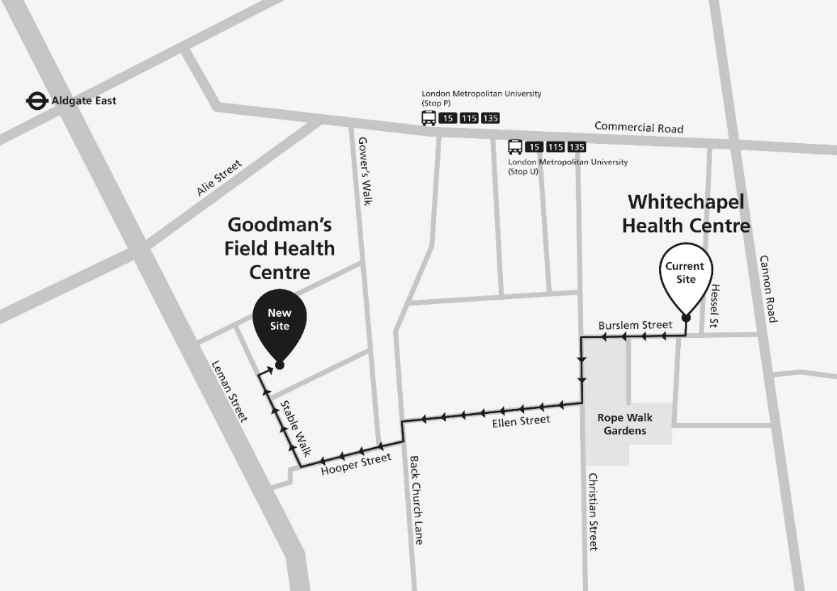

East One Health to Goodman’s Fields Health Centre
