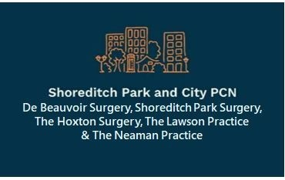
Who are Shoreditch Park & City Primary Care Network (PCN)?
What services can the PCN provide for better health outcomes in our local community?
What Services are available via The Neaman Practice?
What can we do for you?
We want to hear your views and ideas!
Please come along to our Patient Participation Event on
Saturday, 1st April 2023 anytime between 11am-3pm
at
Golden Lane Community Centre, Golden Lane Estate,
London EC1Y 0SA
Refreshments provided

